Commands used to provide the requested operations:

1. For getting the indexes of the adapters and displays present in the system for all the GPUs:

Eyefinity.exe i

the output would be shown in the following format:

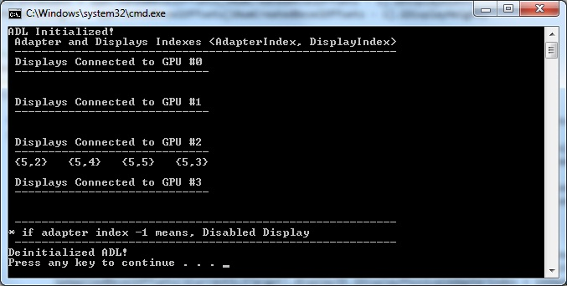

In the above screenshot shown, for GPU 0,1,3 – no displays are connected

For GPU 2 – Adapter index is 5 and display indexes are 2,4,5,3

1. For creating Eyefinity:

Eyefinity.exe e13,2,3 m0,1,2,3,4,5

Here, 13 is the adapter index on which the Eyefinity should be created and the layout type is 2X3 (2 is column and 3 is row)

M is for display indexes – 0,1,2,3,4,5

1. For disabling Eyefinity:

Eyefinity.exe d13

Here, 13 is the adapter index on which the Eyefinity should be disabled

1. For re arranging the displays in Eyefinity:

Eyefinity.exe r13 m0,1,2,3,4,5

Here, 13 is the adapter index on which the Eyefinity is already created.

M is for display indexes – 0,1,2,3,4,5

1. For setting the bezel offsets:

Eyefinity.exe b13 h100 v300

Here, 13 is the adapter index on which the Eyefinity is already created.

H is for horizontal offsets in pixels and v is the vertical offsets in pixels

1. For setting a resolution:

Eyefinity.exe s13 x1920 y1200

Here, 13 is the adapter index on which the resolution should be changed

X is the horizontal resolution and y is the vertical resolution.